**Risk Perceptions and Purification of Water using Graphene Oxide**

Dual Degree Thesis Report

*Submitted in partial fulfilment of the requirements for the degree of Bachelor of Technology & Master of Technology*

by

**Prasham Agrawal**

(Roll No. **160110063**)

Supervisor:

**Prof. Shobha Shukla**



Department of Metallurgical Engineering and Materials Science

INDIAN INSTITUTE OF TECHNOLOGY BOMBAY

(November 2020)

**Declaration**

I declare that this written submission represents my ideas in my own words and where others ideas or words have been included; I have adequately cited and referenced the original source. I also declare that I have adhered to all principles of academic honesty and integrity and have not misrepresented or fabricated or falsified any idea/data/fact/ source in my submission. I understand that any violation of the above will be cause for disciplinary action by the institute and can evoke penal action from the sources, which have thus not been properly cited, or from whom the proper submission has not been taken when needed.

**___________________**

Prasham Agrawal  
160110063

**Approval Sheet**

Dissertation titled ‘Risk Perceptions of Water and Purification of Water using Graphene Oxide’ by Mr. Prasham Agrawal is approved for the Dual Degree (Bachelor of Technology & Master of Technology) in Metallurgical Engineering and Materials Science (MEMS) at IIT Bombay.

**Examiner(s):**

________________

**Supervisor:**

________________

**Chairman:**

________________

**Date: _____________**

**Place: _**____________

**Abstract**

The increased pollution in the world has caused significant contamination in the existing water facilities. It is therefore imperative to understand the risk perceptions of these contaminations to help in the formation of public policies by the institutions. Here, we therefore try to conduct a survey within IIT Bombay to understand the difference in the understanding of the risk perceptions among the 3 sections of the society and how correctly do they perceive the associated risks.

The membranes used in reverse osmosis processes currently are the same which were used 30 years ago. Graphene oxide membranes show signs of being a potential alternative in the membrane technology for water purification. GO membranes have low thickness, high permeability and have nano pores which provide nano channels for water flow.

GO membranes can be a potential substitute but there are few limitations to it. As a result, we are understanding the possibilities of surface modifying the GO membranes with some materials. GO-TiO2 composites seem to be such a composite which counters some of the limitations which were associated with the standalone GO membranes. We’ll look at the properties, synthesis and the filtration properties of such GO-TiO2 composite membranes.

Chapter 1

**Introduction**

The continuous and ever-increasing depletion of our conventional energy resources along with increasing environmental hazards are some one of the major problems that our society is facing today [1]. With these major issues impacting our society, it is now of utmost importance that we come up with new technologies to accomplish a global energy supply which is sustainable. For the same, many companies are working towards the same and are investing heavily to come with newer sustainable energy models.

We can draw a curious analogy between the sun and water. Just like the energy from the sun is abundantly available and we need technologies to trap and harness it in an efficient and economical way. Similarly, we have infinite amount of water available with us in the oceans but problem is that such available water is not fit for human consumption.

The above scenario creates two major problems for us, one is the purification of the available water to make it fit for human consumption and the second, is to understand the risk perceptions associated with the available water which is consumed [2].

As climate change increases the likelihood of competition for water among agricultural, municipal, and environmental users, the need to confront growing risks related to water quality, quantity, and an increasingly fragile infrastructure becomes more urgent. Adapting to these risks requires political will and public support for strategies such as decreasing water use, accepting recycled water (converting wastewater into water that can be used for other purposes), and paying for infrastructure improvements.

Membrane separation technology is considered one of the most important scientific approaches to solve global water crisis. The performance of membrane materials is one of the key factors in the development of membrane separation technology. In recent years, nanomaterials, such as nano-silica, nano-titanium dioxide, nano-silver, aquaporins and carbon nanotubes (CNTs), have been used to develop membranes with optimal structure and performance. A variety of 2D materials, including graphene-based materials were considered for fabricating separation membranes. Among the present nanomaterials, graphene-based materials are the most studied for the preparation of nanoporous membranes, multilayered membranes and mixed-matrix membranes. The results of molecular dynamics simulations showed that the water permeability of nanoporous graphene was several orders higher than that of conventional reverse osmosis membrane. [3]

In this study, we analyse the properties of graphene oxide which makes it an ideal candidate for usage as water purification membranes. Due to the availability of pores coupled with its supreme mechanical strength graphene oxide becomes very apt as a membrane for removal of ions and physical impurities from the impure water. We then look at the surface modification of GO films using TiO2 to make GO-TiO2 composite films and how they improve the filtration properties of GO composites. We look at the properties, the synthesis followed by the change in filtration properties of GO-TiO2 composites as compared to the filtration properties of stand-alone mono layered and multi layered GO membranes.

**2. Survey**

**2.1 Literature review**

**2.1.1 Background**

A broad level literature survey was done and research papers[4-10] which focussed on either water contamination or the risk perceptions were studied. With the ever increasing rise in population of Earth, its necessary to understand both- what is the level of the contamination is in the rivers and what are all the contaminants, and understanding how do people actually perceive these risks. Based on the literature survey done, research papers on a very broad basis (related to our area of concern) could be broken or classified into the following 6 categories:

1. Analysis of the heavy metal impurities and the level of contamination these contaminants have in the water/soil/river near an industrial region
2. Accumulation of heavy metal impurities in the soil and consequently in the vegetable/fruits/crops grown near industrial regions
3. Study of contamination on a broader overall basis through sample collection and testing
4. Risk perceptions of heavy metal contaminations by residents living closer to an industrial region (high-exposure) and who live away from the industrial region (low-exposure)
5. Risk perceptions of water supplies through public or private modes
6. Perceptions on the understanding of water management systems and/or perceptions on usage of alternate modes of water supply

The above 3 categories of research areas focus more on the analysis of the contamination present, what are the contaminants in what quantity and what could be the harmful effects of these contaminants in the human body based on the contamination and consumption level of water through these sources. Whereas the bottom 3 categories discuss and analyse more about the risk perceptions and how do humans understand and accept the water system and what could be the dangers/risks associated with them. Our area of focus in this particular study would be on the bottom 3 areas of research.

**2.1.2 Public water system risk perception Canada**

In this study[9], a postal survey of the residents of Hamilton city in Canada was performed. The aim of the study was to understand the public perception of the risks associated with the public water supplies and eventually using the findings to formulate public awareness and outreach strategies in the geography.

In this part of Canada, residents are themselves responsible for the water supplies they have. A majority of the population uses their own water sources, wells for example. As a result, these water supplies are seldom treated resulting in a huge amount of waterborne diseases in Canada. A staggering 45% of them involve private water supplies.

We’ll cover the methodology and findings of this and subsequent surveys in very brief. The database of the participants was obtained from the local municipality and were randomly chosen such that no selection bias occurs. The questionnaire was then mailed to the survey participants. 450 people were mailed and responses of 246 people were only received. The questionnaire were developed with the help of these earlier studies[].

Fig.1 – Explanations received for concern related to water supplies

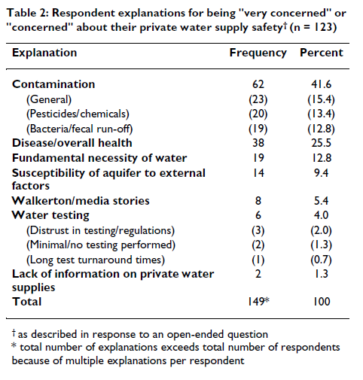

Most respondents evaluated the nature of their private water supplies profoundly and 60% were certain it was alright for utilization. In any case, 80% of respondents announced having probably a few worries with the nature of their water. A conceivable clarification for this clear disparity might be identified with an apparent absence of medical issues.

Fig. – Potential causes for contamination

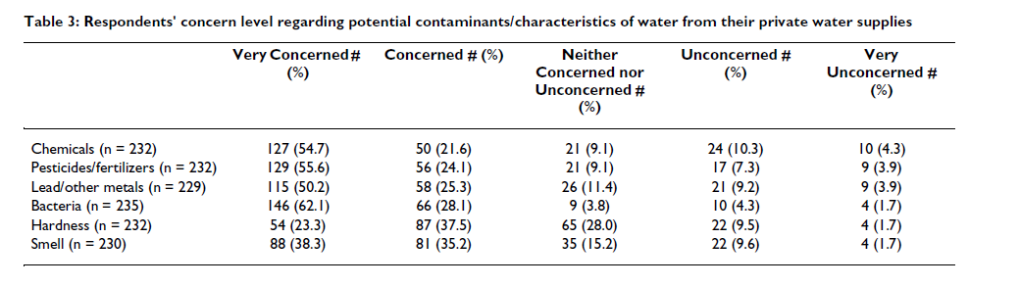

While respondents evaluated their quality profoundly, the larger part had concerns with respect to the water from their personal supply, and the utilization of filtered water and treatment devices for contaminated water was huge. The treatment of water was not frequent due to non-availability or inadequate knowledge about the subject. Hence, there is need for government intervention.

**2.1.3 Public water system risk perception – university study**

In this study[7], the survey participants were college (Indiana University) students both from – environmental and non-environmental backgrounds. The major aim of the survey revolved on the understanding of the students of a prestigious university, and how the understanding/awareness varies for students with environmental and non-environmental backgrounds. The ultimate aim was to use the findings of the survey and use them for addressing measures to advocating shortages in public infrastructure of water management. A total of four fifty seven (457) students participated in the survey.

Fig.2 – Illustration of the ideal route of water as explained by the experts in the domain

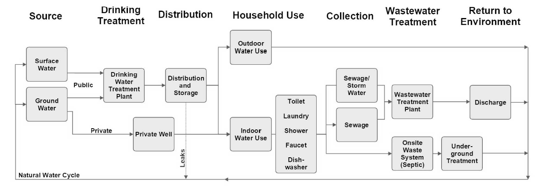

The students were majorly asked to draw what they believe could be the possible route in which the public water system functions. This includes both, the arrival of the water from the source to your taps and also what processes or paths are undertaken after the water flows out from your drains. There were huge gaps in understanding, 0.29 fraction of the people didn’t mention a treatment plant and 0.64 fraction of them didn’t mention a waste-water treatment plant.

Fig.3 - %students who mentioned each of the aspects of the water cycle in their answer

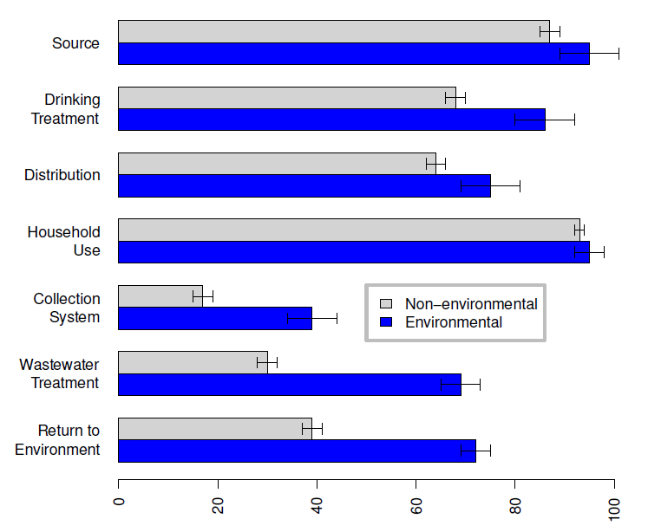

Students were also asked upon what they believe could be the major sources of contamination, quality,aquantityaorainfrastructure. The results are mentioned in the below table.

Fig.4 - As % of entire responses, problems with Quality, aQuantityaoraInfrastructure

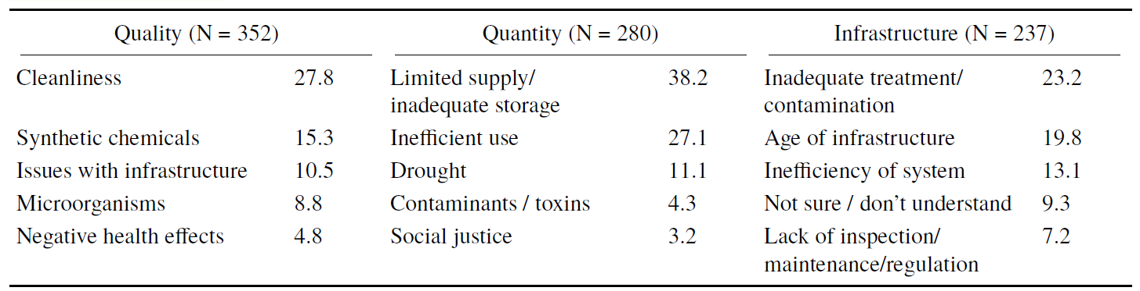

The study shows that are some pivotal misunderstandings with respect to how the water treatment process works in a society. Results of the study show that even university students are unaware about a lot of processes which are carried out. This tells us that the governments need to step in and think about how would they be going about in the educating the masses. Since there are misunderstandings about the process in itself, its clearly evident that there would be gaps in understanding the risks associated with the same.

**2.2 Survey Preparation**

Based on the learnings of the various studies[4-10] which were conducted in this domain of research, we are planning to conduct a survey on our own to understand what is the current risk perceptions and readiness to accept changes, before we move on to synthesize our GO water filtration membranes.

**2.2.1 Aim**

The aim of this survey is to understand the awareness amongst the people, their understanding of risk perceptions and their readiness to learn bring a change starting from themselves. We’d like to understand how these parameters vary within the different sections of society. Based on the findings of the survey, we’ll get a better understanding about the perceptions of the community and hence, what could be the potential ways for the administration to tackle this situation and make the conditions better. It will also give us a qualitative understanding about whether there is a need in the society as well as their readiness to accept/explore new kinds of filtration techniques. Since the survey will be conducted only for the domestic population, market readiness only for domestic consumption could be understood and not really the aspects related for commercial industrial usage.

**2.2.2 Survey Target Group**

The survey will be conducted for the residents of IIT Bombay. The target groups are all the 3 major broad categories of people in the institute – students, staff and faculty. The survey will aim at understanding how the risk perceptions and the understanding varies for the 3 different categories of people. These 3 sections are taken as the target groups given the assumption that the 1st section – faculty, would have the highest knowledge and awareness and the staff would have the lowest. Students should lie somewhere in between. The results of the survey will help us in justifying or validating this hypothesis.

**2.2.2 Questionnaire development**

The studies mentioned above were analysed thoroughly and the observations and learnings from the above studies were applied to develop our questionnaire. The questionnaire aims at addressing the following major areas – awareness about water supply channels in IIT Bombay, risk perceptions related to non-drinking water, risk perceptions associated with drinking water and water purifications used, recognizing water scarcity as a problem, need & readiness to accept new purification systems and readiness to accept ways to reduce water scarcity as a problem. The survey contains questions both which require ratings on questions on a scale of 1 to 10 and also multiple choice questions. Efforts have been made to avoid open-ended questions and just restrict to close ended questions.

The following is the [link to the survey](https://forms.gle/LEMy8VW6eYW1cnP1A).

**2.2.3 Further Plan of Action**

The survey would be floated on the mailing system of IIT Bombay in the coming months. Once the survey is floated, sufficient time would be given to fill up the survey. Post collection of responses, the responses would be analysed for the further course of action.

------

Membrane technologies play an important part in the water purification units used all around the world. With the results of the survey we’ll be able to understand the current scenario and also what demand and potential exists for new technologies in the market. In the next section, we look in detail about how membrane technologies are an important component of the water filtration systems used and look at Graphene Oxide membranes as one of the promising future material in the applications of water purification.

------

**3. Water Purification by Membranes**

One of the most prominent technologies for water purification currently in use is the water separation using membranes, and particularly the most significant one is the Reverse Osmosis i.e. RO technology. We’ll look in to the RO technology in detail and how important role does a membrane play in the entire process.

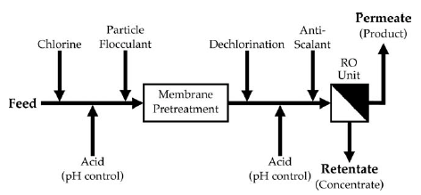**3.1 Membrane Separation as a Unit Operation**

Fig 5 – A flow chart displaying a simplified process of water purification  
using two membrane technology, pre-treatment and then salt treatment [11]

In the above example, it comprises of basically two separation steps by membranes, a pre-treatment unit for suspended impurities, present macromolecules and removal of particulates followed by a salt removal process by reserveiosmosisi (RO). There are several other process in the flow diagram like, chlorine addition,iparticleiflocculation andipHicontrol.

The desalination process using GO membrane is discussed first, followed by the surface modification of GO films using TiO2 to remove the organic impurities as well.

**3.2 Osmotic Pressure**

Dispersed solutes in a watery feed make an osmotic pressure, p, thermodynamically defined in terms of the activity of the dissolvable (water) in the solution

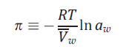

where Vw is the partial molar volume of the solvent, R is the gas constant, T is the total temperature, and aw is the activity of the solvent.

For adequately weaken arrangements, the above equation improves to the notable van't Hoff equation

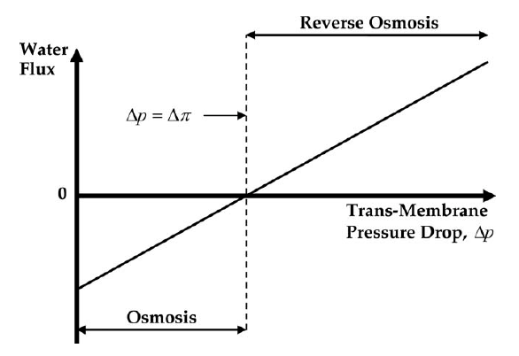where Cs is the molar concentration of the solute. To achieve a significant water flux across the membrane, there must be an external pressure applied to the system. To create a water flux, the applied external pressure should be significantly greater than the osmotic pressure across the membrane. As a result, can be positive – from higher to lower solution concentration or it could be negative – from lower to higher solution concentration depending on the external pressure applied to the system.

Fig. 6 - Membrane flux versus an applied trans-membrane pressure

difference, Δp, with a given osmotic pressure difference, Δ π. [12]

**4. Principle behind using Graphene Oxide for Water Purification**

**4.1 Background**

As discussed above, most of the membrane technologies used today depend on the reverse osmosis (RO) desalination process. But, to desalinate a large amount of seawater, the existing technologies are quite expensive and hence, the development of more permeable energies are necessary to reduce the required energy consumption and hence the associated costs. Any change in the required pressure application for RO process can distinguishably change the membrane output. In a tudy it was found that the required pressure for desalination of brackish water and seawater was decreased by 63% and 44% respectively by using a membrane which had three times the permeability as compared to the initial one. Since the total cost of water desalination is approximately 50% dependent on the energy consumption, the reduction in energy consumption during water purification is of utmost importance.[13]

The still widely used RO membrane are based on the designs which were designed around 30 years back and are polyamide thin-film composites. The most permeable thin film composite membranes as compared to 20 years ago, provide a permeability which is greater only 1.5-2 times the previous ones. A much developed version of a RO membrane is must to respond the challenges the of the coming years and also these existing membranes become dysfunctional and get damaged when on repeated contact with chlorine. [13]

Graphene membranes on the other hand are much more chemically resistant, stronger as well as thinner as compared to the classic polyamide thin-film composite layers in the RO membranes. Since the atomic thickness of graphene layers (d~= 0.34nm) is much smaller than the thickness of thinfilm composite membranes (d~=100 nm) and since the thickness is inversely proportional to the water flux through a membrane, the graphene layers have a much higher water permeability as compared to the polyamide layer in thinfilm composite membranes. Graphene Oxide also has a higher lifetime as it shows some antimicrobial properties, lowering the membrane fouling and hence lowering the energy used in the purification process of water. [13]

**4.2 Graphene Oxide membrane**

Graphene can promptly be handled into a layer for application as RO and nanofiltration (NF) (an ease and profoundly effective detachment method among ultrafiltration and RO) desalination films. For such reasons, broad research is presently being completed to understand its potential as a next-generation desalination membrane. At the current state, graphene layers have appeared in significance to water desalinating NF films. Without anyone else's input, they can desalinate exclusively somewhat harsh water and have demonstrated RO capacity by means of recreation contemplates too. For seawater desalination, thinking about the a lot bigger salt focus, the layers should be fundamentally changed. [14]

**4.3 Graphene Nanomaterials for Water Purification**

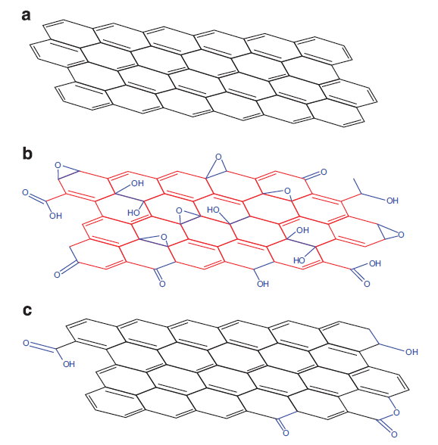Graphene is a two-dimensional (2D) 1-atom thick planar sheet of sp2-fortified carbon molecules. The principal combination of graphene, utilizing scotch tape and a bit of graphite, goes back to 2004. This material shows astounding physical, mechanical, heating and optical properties, which have been featured in many territories of science and designing. The sp2 bonds and the included electron design are the fundamental purposes behind the ultra-high mechanical quality and flexibility, modifiable electronic band gap, great heat (5300WmK− 1) and electrical conductivity (2000 S cm− 1) and room-temperature Hall impact of graphene. Its hardness is

Fig 7 – Structural models of (a) single- layer graphene, (b) GO and (c) rGO [16]

more than multiple times higher than that of diamond and multiple times higher than that of steel. [15]

With respect to partition, graphene has a nuclear thickness, guaranteeing its high liquid porousness (a few overlap higher than that of most business NF layers) and in this way vitality/cost effectiveness. Furthermore, there is great potential for size-particular transport through the nanopores of a very powerful graphene layer or 2D nanochannels between adjoining stacked graphene sheets. The creation of graphene-based layers for desalination is additionally clear.

Graphene can be utilized for the development of desalination films in different structures, for example, immaculate graphene, GO and reduced GO (rGO) (Figure 3). Flawless graphene is a solitary 2D layer of carbon particles sorted out in a hexagonal example. Layered oxygenated graphene sheets, that is, those including oxygen utilitarian gatherings, for example, epoxides, carboxyls, hydroxyls and alcohols, on their basal planes and edges, are called GO.23,24 GO is made through oxidation of characteristic graphite chips by utilizing solid oxidants, for example, KMnO4, KClO3 or NaNO2, alongside a solid corrosive, for instance, concentrated sulfuric corrosive or nitric corrosive. Hence, single GO sheets can be peeled by ultrasonication. A GO sheet is predominantly made out of unblemished (16%) and oxidized areas (82%) with a unimportant level of openings (2%). In this structure, the disconnected unblemished areas are bound by the ceaseless oxidized domains.18 Through decrease forms, for example, concoction decrease, electro-decrease, warm strengthening, streak decrease and enzymatic decrease, GO is changed over to rGO with some remaining oxygen and auxiliary deformities. [15]

**5. Graphene Desalination membranes**

Graphene nanomaterials can be viewed as building squares of cutting edge desalination films primarily with two structures: monolayer and stacked multilayer.

**5.1 Monolayer Graphene Desalination membranes**

Attributable to the arrangement of a thick and delocalized electron cloud from the π-orbitals of graphene, which hinders the voids inside its aromatic rings, immaculate graphene is impermeable. Along these lines, even He (as the littlest monoatomic particle with a sub-atomic span of 1.3 Å) can't go through it. However, as indicated by reproductions, by the incorporation of pores of controlled size, thickness and usefulness, graphene layers can outperform current desalination films, appearing of extent higher porousness and selectivity (refer the figure below)

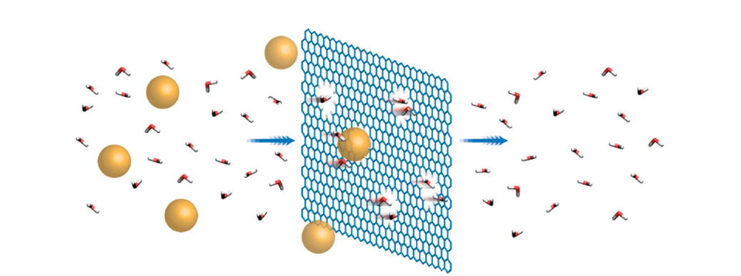Fig. 8 - A graphene layer with subnanometer pores as a RO film. In this procedure, the salt water (left), exposed to a high pressure, is partitioned into two sections: water atoms (red and white) going through the layer (right) and salt particles (golden) that are blocked. [17]

The reason for the ultrahigh water penetrability of graphene, which converts into a remarkable decrease in the underlying capital speculation and working expenses of desalination plants, is its nuclear thickness. In this manner, the making of controlled pores regarding size, thickness and usefulness in a graphene structure guarantees the advancement of a very specific and, in the meantime, penetrable layer for water desalination. Such favorable circumstances have drawn the consideration of scientists to research the filtration abilities of graphene tentatively and through recreations.

**5.1.1 Problems**

Apart from analysing simulations, various pertinent trial examines have additionally been performed. These investigations demonstrated the precision of reproduction forecasts with respect to the high effectiveness of graphene layers for water desalination. Besides, they tended to current difficulties in the improvement of monolayer graphene layers for modern applications. In such manner, the primary difficulties incorporate the accompanying: (1) the minimal effort creation of extensive region monolayer graphene; (2) the age of high-thickness nanopores with controlled uniform sizes and substance functionalities on the graphene sheet; and (3) the characteristic and outward deformities framed amid development and graphene exchange forms. [17]

**5.2 Multilayer Graphene Desalination membranes**

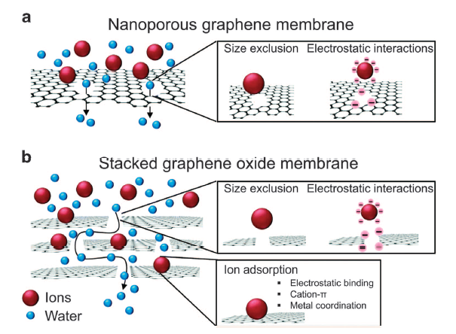In spite of the noteworthy advantages of monolayer graphene films, particularly as far as water porousness, the manufacture of release free, large area monolayer graphene layers with Fig. 9 –schematic of the separation mechanism of a) monolayer graphene membrane with nanopores of controlled size and b) a multilayer graphene membrane composed of stacked GO sheets [18]

controlled pore thickness and size on the modern scale is testing. One answer for this test is the manufacture of desalination films dependent on stacked GO nanosheets. These nanosheets are exceptionally stackable, principally because of their structure, a solitary iota thick layer with a sidelong measurement achieving several micrometers. Strong interlayer hydrogen bonds hold the GO sheets together to frame a stable detached film. In addition, GO nanosheets can be delivered on a substantial scale with ease by means of concoction oxidation and the ultrasonic peeling of graphite. This strategy guarantees the cost proficient and modernly material manufacture of stacked layers. At long last, 2D graphene offers remarkable synthetic and warm strong qualities as well as unrivaled adaptability and arrangement processibility.

As shown in the above figure , GO sheets can be arranged as highly ordered films with 2D nano-channels between two adjacent graphene sheets. This disallows the passing of undesired solutes while enables the penetration of water because of the 2D channels formed as a result of this structure. Moreover, in the existence of oxygen-containing functional groups, for example, carboxyl gatherings, in a hurry nanosheets empowers functionalization and in this way empowers related accuse based collaborations of water pollutants. Such encouraging highlights make multilayer GO structure a perfect possibility for the generation of cutting edge ionic and sub-atomic sieving films for desalination.

**5.2.1 Problems**

Albeit various investigations have demonstrated the appropriateness of this class of films for water desalination, specifically as NF layers, numerous examinations in the writing have tended to flow difficulties. There are a few difficulties in front of the modern utilization of multilayer graphene films. These difficulties incorporate the accompanying: (1) swelling, (2) water unsteadiness, (3) low mechanical toughness and (4) adaptability. Also, such layers have indicated exclusively a constrained NF desalination ability. Therefore, to broaden the appropriateness from NF desalination to seawater desalination, particle dismissal must be additionally upgraded. [18]

**6. GO-TiO2 as a Water Filtration Membrane**

**6.1 Background**

Membranes using Graphene Oxide as a material are nor fairly gaining a lot of traction because of the superior mechanical, permeable and hydrophilic nature of GO. The basic process used in Water Filtration is a usage of membrane which allows water to selectively pass through it and restricts or adsorbs the dyes or other contaminants which are present in it. There are majorly 3 ways in which Grapene Oxide is used as a material in water filtration:

1. Graphene Oxide as a standalone membrane
2. Surface Modification of a polymer film using Graphene Oxide
3. Membranes made using a composite material using Graphene Oxide [19]

While graphene oxide films could be used as a standalone material, there are quite a few challenges associated with it. Standalone GO films don’t have the appropriate number of pores or capillaries which could allow a significant flux of water to pass through them. Also, if multi-layered stacked GO films are used, they are bonded closely with each other. The GO films contain presence of oxygen containing such as hydroxyl groups which results in Hydrogen bonded forces between multiple layer of films. As a result, these pores are metastable and become dis-functional when used for a longer duration of time, devoiding them in usage of large scale potential industry applications.

Now with a desire to counter the above mentioned films, we are interested in formation of GO-TiO2 composite films.

**6.2 Why GO-TiO2 films?**

As we discussed above, there is meta-stability due to the attraction forces between the multilayers of GO films, which make them unstable, reduce the pores size and contract the capillary spaces which are present between the GO sheets.

Fig. 10 - Potential fluid passage through (a) standalone GO films (b) graphene modified composite membranes [20]

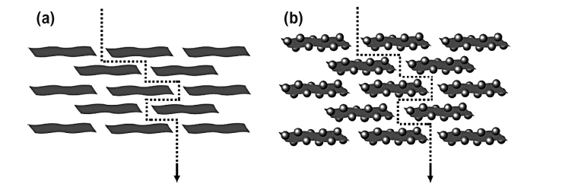

To solve this problem, we can imagine that introduction of some rigid particles, which could stablilize the films from collapsing (as shown in the figure), would also help in broadening the narrow channel pores among the multi-layered GO sheets, making them more durable and also increasing the total flux of water. This would result in formation of a robust and a durable water filtration membrane.

Here we’d like to focus on the usage of GO-TiO2 composite films which could counter all the above mentioned problems and could be used as a potential innovation in the water filtration industry. The prepared films are tested with the passage of dyes – metyl orange and rhodamine, results show that the made GO-TiO2 films are able to adsorb additional amounts of dyes, making them a potential film to be used in the water purification industry.

**7. Synthesis of GO-TiO2 composite films**

**7.1 Synthesis of rGO by improved Hummers’ method**

GO is primarily synthesized by chemical oxidation of natural graphite, although there are some reports of alternative electrochemical oxidation. Through applying potassium chlorate to the graphite slurry in fuming nitric acid, Brodie first synthesized graphite oxide. Staudenmaier developed this approach after about 40 years through replacing about two-thirds of fuming HNO3 with concentrated H2SO4 and feeding the chlorate in lots. In 1958, Hummers and Offeman[21] developed an alternative oxidation method, often called Hummers, in which NaNO3 and KMnO4 dissolved in concentrated H2SO4 were used within a few hours to oxidize graphite into graphite oxide. But it still suffers from a range of drawbacks, including toxic gas (NO2, N2O4), residual nitrate and low yield.

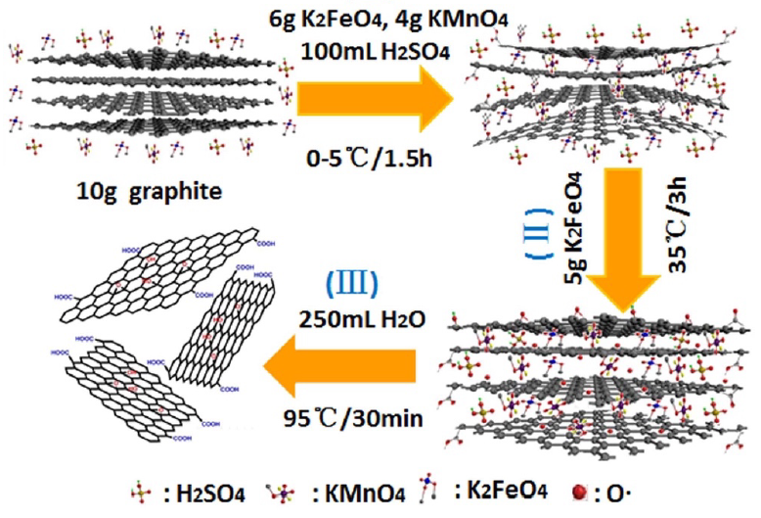  
Fig. 11 - Illustration of preparation of GO based on the improved Hummers’ method

To address these problems, various modification on Hummers’ method have been made in the past 20 years, and the main strategies can be summarized as follows:

1) Removing NaNO3 directly from Hummers method with an improved workup

2) Adding a step of pre-oxidation before KMnO4 oxidation (in the absence of NaNO3)

3) Increasing the amount of KMnO4 instead of NaNO3

4) Replacing KMnO4 with K2FeO4 while NaNO3 was removed

Through that both KMnO4 and concentrated H2SO4 (containing 1/9 H3PO4) in place of NaNO3, Marcano found that the improved Hummers approach leads to higher yield and the temperature can be regulated easily.

In this method, Graphite (3.0g) is added to around 70 ml of concentrated sulphuric acid at room temperature under constant stirring, 1.5g of sodium nitrate is then added and then the mixture is cooled to 00 C. While vigorously agitating the mixture, around 9.0 g of potassium permanganate is added. The mixture is then transferred to a water bath for around 0.5 hrs kept at a temperature of 35-400 C, which eventually forms a thick paste. 140 ml of water is then added, continuously stirring the solution for another 15 min. 500 ml of water is further added to the solution and then 20 ml of 30% H202 is added slowly, which turns crown coloured solution to yellow. The mixture is then filtered and then further washed with a 1:20 HCl aqueous solution (250 ml) to remove the metal ions and this process is repeated to remove metal ions present in the solution. The mixture is then diluted with water and then centrifuged to get rid of all the acid used for washing. The resulting solution is then dispersed in water while stirring for an entire night and then, a GO aqueous dispersion is obtained. Dialysis of the resulting dispersion is then done for 2 weeks to get rid of all the salt impurities as well as the remaining acid. The mixture is then again centrifuged for 30 min at 4000 rpm to remove aggregates. [22]

Two problems remain in various modified versions of the Hummers method:

(1) high oxidant consumption and intercalating agents are inevitable

(2) most of the synthesis routines were pro-ceased for a long time, both resulting in high cost

and low scalability in practical applications.

**7.2 Synthesis of GO-TiO2 films by vacuum filtration**

**7.2.1 Formation of GO composites**

A dispersion can be created using 25mg of graphene oxide and 60mg of titanium sulphate in ~40ml of water and then heating the mixture for 24 hours at 60 degrees centigrade. To remove any contaminants or impurities in the solution, centrifugation followed by washing it 5 times with distilled water should be carried out. To form stable dispersions, pH of the solution must be increased. Ammonia is added for the same. A value of pH=10 is preferred. [23]

Fig. 12 – A proposed scheme for the formation of GO-TiO2 films starting from GO[23]

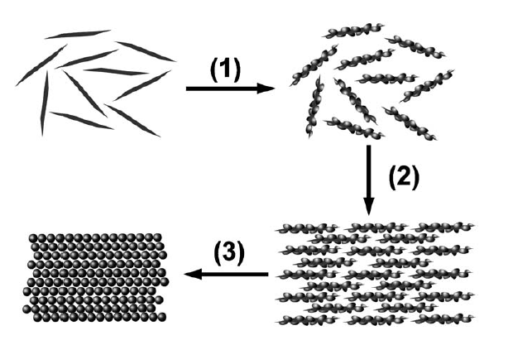

**7.2 Synthesis of freestanding GO-TiO2 films**

Fig. 13 – Process schematic of the preparation of free-standing GO-TiO2 film[24]

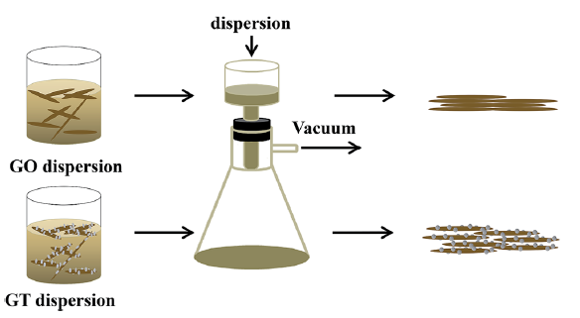

The obtained composite sample is then centrifuged and then again rinsed with distilled water for roughly around 5-6 times to remove any contaminants which might still be present. The now obtained GO-Tio2 composite is then again dispersed in 20-25 mL of DI water. A free-standing membrane is now prepared by using 20-25 ml of the composite solution obtained. A cellulose acetate membrane of 2.5 cm radius and 0.20 micro-meters as the size of the pores is taken. The obtained GO-TiO2 solution is prepared by using vacuum filtration on the cellulose acetate membrane. The film is now peeled off from the cellulose acetate membrane and is followed by drying. Finally, the film is reduced thermally in an argon atmosphere. [23]

**8 Research Objectives**

**8.1 Characterization of GO-TiO2 films**

The characterization of the GO-TiO2 is studied to understand the properties of the films which could be obtained using the above mentioned methodology.

Fig. 14 – TEM images of GO-TiO2 films[25]

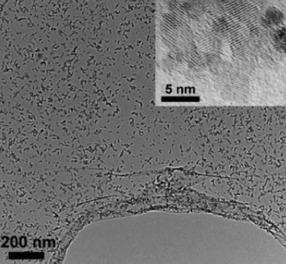

It is understood that some amount of TiO2 is present on the surface of the GO-TiO2 composite films obtained. To calculate the actual amount of TiO2 present on the GO-TiO2 composite films, TG analysis could be done. TG analysis in the study showed that ~42%[26] of the surface is occupied by the introduced TiO2 molecules.

Fig. 15 – TG analysis of GO-TiO2 composite film[26]

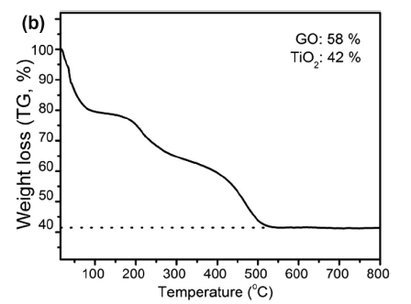

X-Ray Diffraction patterns of the characterized films suggest a 2-theta value of 11.6[27] degrees for the non-modified GO films. A 2 theta value more than 2 times (=26.5 degrees) is obtained for GO-TiO2 composites, indicating an increased inter-planar spacing between the GO-TiO2 sheets, satisfying one of the major objectives that we were looking for.

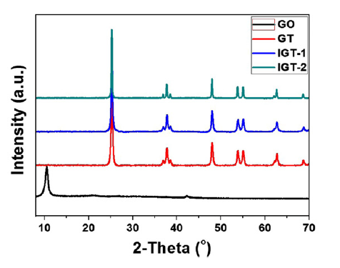  
Fig. 16 – XRD patterns of GO-TiO2 composite films[27]

The wettability of the membrane is an important factor to understand its filtration properties. A lower contact indicates a higher affinity for water. Contact angles were measured[28] and it was found that standalone GO films have a contact angle of 29.5 degrees which decreased to 19.7 degrees for the the GO-TiO2 films, indicating a better wettability of the GO-TiO2 composite films.

Fig. 17 – Contact angle of (a) GO = 29.50 (b) GO-TiO2 = 19.70 [28]

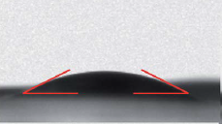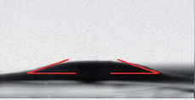

Another major concern for using the stand-alone graphene oxide (GO) films was that when using them in a multi-layered mode, the films/sheets were attracted to each other because of hydrogen boding between the sheets due to the presence of oxygen containing functional groups on the sheets.

To understand whether the new formed GO-TiO2 composite would overcome that, nitrogen adsorption isotherms of the obtained GO-TiO2 films be plotted and specific surface are from the same could be evaluated. A study did the same, and using the nitrogen adsorption-desorption isotherms found that the specific SA of GO/TiO2 films to be about 488.2 meter^2/gram[25]. The value of specific surface area obtained is much greater than either the specific surface areas of graphene oxide sheets (< 9.9 meter^2/gram) and TiO2 (~119.2 meter^2/gram). This implies that the sheets obtained have a better separation of the different sheets stacked together.

Fig. 18 – Nitrogen adsorption-desorption isotherms of GO-TiO2 film[25]

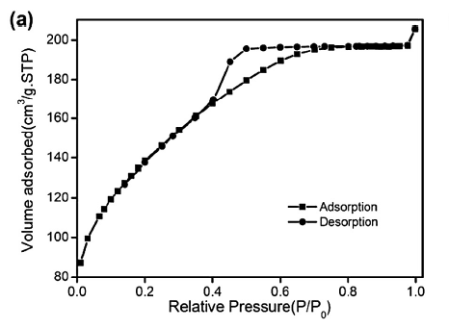

**8.2 Filtration properties of GO-TiO2 films**

The major objective of this research is to understand the filtration properties of the GO-TiO2 composite and to understand whether they propose a solution for being a potential membrane in the water filtration technology. To understand the filtration properties of the GO-TiO2 composite films, the obtained films were used to filter two types of dyes – methyl orange and rhodamine B. The obtained films and filtrate were analysed.

Fig. 19 – A schematic of a similar observed adsorption/desorption behaviour of rhodamine B in  
GS. (a) GS in rhodamine B at the start. (b) after 3 hrs (c) GS taken and placed in ethanol, at start (d) after 10 minutes. [29]

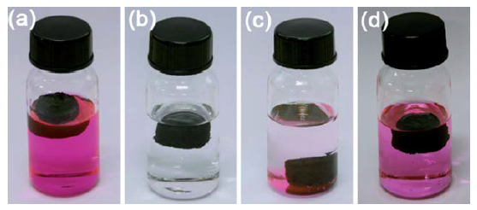

As shown in the above figure, the methyl orange and rhodamine B solution was passed through the GO-TiO2 composite films. The fig(a)&(b) shows the adsorption or the filtration behaviour within a time span of 3 hrs and fig (c)&(d) show the desorption behaviour when placed in ethanol solution for 10 minutes.

Fig. 20 – (a) Ultraviolet-visible absorb spectrum for different amounts of methyl orange solutions (b) variations in the retained dye amount and the %adsorption of the methyl orange solution[30]

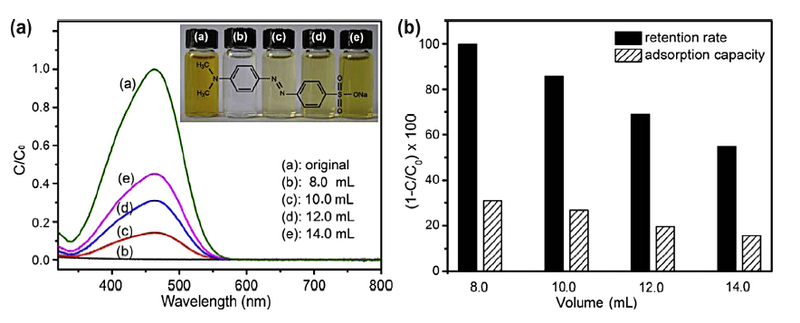

Filtration of methyl orange solution from the GO-TiO2 can be first discussed. A methyl orange solution having a concentration of 10 parts per million was taken and then filtering the solution from the GO-TiO2 film is observed. Different volumes of the methyl orange were taken one-by-one to understand the variation in the filtration properties with the changing volumes. A very strong green-yellowish color of methyl orange solution was present before filtering. After filteration, the colour substantially decreased denoting a significant filtration of the methyl orange molecules, but started increasing with the increase in volume of the methyl orange solution. A high efficiency ~1 was obtained as long as the volume of the methyl orange solution was <8 mili-litres. An ultraviolet-visible absorbance of the obtained filtered solution was recorded as displayed in the fig x(a).

Different volumes of the methyl orange solution were taken (8ml, 10ml, 12ml and 14ml) and the experiment was repeated. As mentioned before, the filtration properties started degrading with increasing volume, indicating passage of some methyl orange molecules with increasing volume. Fig x(b) shows the variation in the retention rate and adsorption capacity of the GO-TiO2 films with the varying volume. Retention rate indicates the %dye which was filtered in the process and the adsorption capacity indicates the %dye adsorbed by the GO-TiO2 films. It can clearly be seen that there is a difference in the amount of dye filtered vs the amount of dye adsorbed by the film, indicating there another phenomenon which is resulting in the retention of dye from being passed on to the filtrate.

Fig. 21 – (a) Ultraviolet-visible absorb spectrum for different amounts of rhodamine B solutions (b) variations in the retained dye amount and the %adsorption of the rhodamine B solution[30]

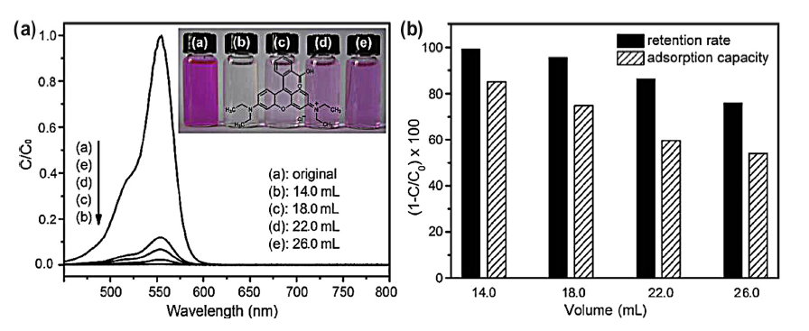

A similar experiment was done for the rhodamine B dye solutions and the results are shown in the above fig y. Interesting to observe that adsorption capacity is higher for the rhodamine B solution as compared to the methyl orange dye solution.

**9 Summary & Future work**

Understanding of the risk perceptions associated with water play an important role in the development of policies for public systems. The risks associated could be either actual because of poor infrastructure, improper sanitation or diseases caused by impurities in water. The risks could also be psychological depending on the level of awareness of a person. A survey conducted in IIT Bombay will help us in understanding the above aspects in detail.

Alternate ways of water purification are an important requirement of time. GO has come out be a promising material in water filtration using membrane technology. Virgin GO membranes can separate metal ions but are unstable in nature. The GO membrane properties could be enhanced by surface modification using GO-TiO2 composites. The GO-TiO2 have shown promising results in terms of mechanical strength, surface properties as well as the purification achieved using methylene blue and rhodamine B dyes.

**9.1 Future Work**

1) Floating the survey in IIT Bombay and collecting as many responses as possible. The survey to be floated among the 3 sections within the campus, students, staff and faculty. Analysis on the collected responses will be performed. The analysis will help us in understanding the risk perceptions by the residents of the campus as well as the difference in understanding among the 3 sections of the society.

2) Improvement in the formation of graphene oxide with altercations in the experimental conditions. Using alternate techniques apart from the vacuum filtration method. Experimentally forming the GO-TiO2 composites and characterization of the formed films. Understanding the difference in the filtration properties of alternate metal oxide GO composite membranes. Trying to form a prototype to form a working membrane for household and/or industrial purposes.

**References**

1. Frank J. Bove, Mark C. Fulcomer, Judith B. Klotz, Jorge Esmart, Ellen M. Dufficy, Jonathan E. Savrin, “Public Drinking Water Contamination and Birth Outcomes” (1995)
2. RGM Wang, “Water contamination and health: integration of exposure assessment, toxicology, and risk assessment” (2020)
3. Yi Wei, Yushan Zhang, Xueli Gao, Zhun Ma, Xiaojuan Wang, Congjie Gao “Multilayered graphene oxide membranes for water treatment: A review” (2018)
4. Paul M. Jakus, W. Douglass Shaw, N. Nguyen, and Mark Walker, “Risk perceptions of arsenic in tap water and consumption of bottled water” (2009)
5. Dirk Grasmu and Roland W. Scholz, “Risk Perception of Heavy Metal Soil Contamination by High-Exposed and Low-Exposed Inhabitants: The Role of Knowledge and Emotional Concerns” (2005)
6. K. K. Pobi, S. Satpati, S. Dutta1, S. Nayek, R. N. Saha, S. Gupta, “Sources evaluation and ecological risk assessment of heavy metals accumulated within a natural stream of Durgapur industrial zone, India, by using multivariate analysis and pollution indices” (2019)
7. Shahzeen Z. Attari, Kelsey Poinsatte-Jones, Kelsey Hinton, “Perceptions of water systems” (2017)
8. Diane Dupont, Cheryl Waldner, Lalita Bharadwaj, Ryan Plummer, Blair Carter, Kate Cave, and Rebecca Zagozewski, “Drinking Water Management: Health Risk Perceptions and Choices in First Nations and Non-First Nations Communities in Canada” (2014)
9. Andria Q Jones, Catherine E Dewey, Kathryn Doré, Shannon E Majowicz, Scott A McEwen, Waltner-Toews David, Mathews Eric, Deborah J Carr and Spencer J Henson5, “Public perceptions of drinking water: a postal survey of residents with private water supplies” (2006)
10. Victoria L. Ross, Kelly S. Fielding, Winnifred R. Louis, “Social trust, risk perceptions and public acceptance of recycled water: Testing a social-psychological model” (2014)
11. Geoffrey M. Geise, Hae-Seung Lee, Daniel J. Miller, Benny D. Freeman, James E. McGrath, Donald R. Paul, “Water Purification by Membranes: The Role of Polymer Science” (2010)
12. Muhammad Qasim, Mohamed Badrelzaman, Noora N. Darwish, Naif A. Darwish, Nidal Hilal, “Reverse osmosis desalination: A state-of-the-art review” (2019)
13. Kris Erickson, Rolf Erni, Zonghoon Lee, Nasim Alem, Will Gannett, and Alex Zettl, “Determination of the Local structure of Graphene Oxide and Reduced Graphene Oxide” (2010)
14. Yongchen Lieu, “Application of Graphene Oxide in Water Treatment” (2017)
15. Thanaraj, Paramasivan & Sivarajasekar, N & Sivaramakrishnan, Muthusaravanan & Subashini, R & Prakashmaran, J & Sivamani, Selvaraju & Koya, Ajmal, “Graphene Family Materials for the Removal of Pesticides from Water” (2019).
16. Yanwu Zhu, Shanthi Murali, Weiwei Cai, Xuesong Li, Ji Won Suk, Jeffrey R. Potts and Rodney S. Ruoff, “Graphene and Graphene Oxide: Synthesis, Properties,

and Applications” (2010)

1. Sumedh P. Surwade, Sergei N. Smirnov, Ivan V. Vlassiouk, Raymond R. Unocic, Gabriel M. Veith, Sheng Dai & Shannon M. Mahurin, “Water desalination using nanoporous single-layer graphene” (2015)
2. Shahin Homaeigohari and Mady Elbahri, “Graphene Membranes for Water Desalination” (2017)
3. Hanaa M. Hegab and Linda Zou, “Graphene oxide-assisted membranes: Fabrication and potential applications in desalination and water purification” (2015)
4. Huiyuan Liu , Huanting Wang , and Xiwang Zhang*, “*Facile Fabrication of Freestanding Ultrathin Reduced Graphene Oxide Membranes for Water Purification” (2015)
5. Hummers, W. S, Offeman, “R. E. Preparation of Graphitic Oxide” (1958)
6. Ning Cao and Yuan Zhang, “Study of Reduced Graphene Oxide Preparation by Hummers’ Method and Related Characterization” (2015)
7. Xu C, Chen Z, Fu X. “Graphene oxide-mediated formation of freestanding, thickness controllable metal oxide films” (2011)
8. Jinsu Kim, Wai-Hwa Khoh, Boon-Hong Wee and Jong-Dal Hong, “Fabrication of flexible reduced graphene oxide–TiO2 freestanding films for supercapacitor application” (2015)
9. Xiaoju Yan, Lu Huo, Cong Ma and Jinfeng Lu, “Layer-by-layer assembly of graphene oxide-TiO2 membranes for enhanced photocatalytic and self-cleaning performance” (2019)
10. Dongting Wang, Xin Li, Jianfeng Chen, Xia Tao, “Enhanced photoelectron catalytic activity of reduced graphene oxide/TiO2 composite films for dye degradation” (2012)
11. Yu Lin Min, Kan Zhang, Wei Zhao, FangCai Zheng, YouCun Chen, YuanGuang Zhang “Enhanced chemical interaction between TiO2 and graphene oxide for photocatalytic decolorization of methylene blue” (2012)
12. Ariffin S.N., Lim H.N., Jumeri F.A., Zobir M., Abdullah A.H., Ahmad M., Ibrahim N.A., Huang N.M., Teo P.S., Muthoosamy K., Harrison I., “Modification of polypropylene filter with metal oxide and reduced graphene oxide for water treatment” (2014)
13. Jinping Zhao, Wencai Ren and Hui-Ming Cheng “Graphene sponge for efficient and repeatable adsorption and desorption of water contaminations” (2012)
14. Chao Xu, Aiju Cui, Yuelian Xu, Xianzhi Fu, “Graphene oxide–TiO2 composite filtration membranes and their potential application for water purification” (2015)
15. B. A. Bhanvase, T. P. Shende & S. H. Sonawane “A review on graphene–TiO2 and doped graphene–TiO2 nanocomposite photocatalyst for water and wastewater treatment” (2017)